Pokhara University

Level: Bachelor | Semester – Spring | Year : 2007
Programme: BE |  | Full Marks: 100
Course: Applied Mechanics |  | Time : 3hrs.

Candidates are required to give their answers in their own words as far as practicable.
The figures in the margin indicate full marks.

Attempt all the questions.

 | - Explain the concept of particles, rigid body and free body diagram. What are the guidelines for drawing a good free body diagram?  - A plate measuring 6 m × 4 m is acted upon a set of forces in its plane as shown in figure. Determine (i) a force couple system at A (ii) the perpendicular distance to the resultant force from point A.  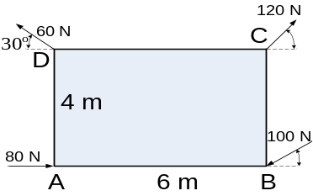 | 8  7
 | - A block of weight W₁ = 1290 N rests on a horizontal surface and supports another block of weight W₂ = 570 N on top of it as shown in fig. Block of weight W2 is attached to a vertical wall by an inclined string AB. Find the force ‘P’ applied to the lower block, that will be necessary to cause the slipping to impend.  Coefficient of friction between blocks (1) and (2) = 0.25  Coefficient of friction between (1) and horizontal surface = 0.40  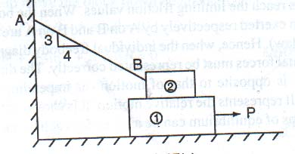  - Locate the centroid of the area shown in figure bounded by the two curves y = x³ and y² = 3x.  y² = 3x  y = x³ | 8  7
 | - The acceleration of a particle is defined by the relation a = 9 – 3t². The particle starts at t = 0 with v = 0 and x = 5 m. Determine i) the time when the velocity is again zero, ii) the position and the velocity when t = 4 seconds and iii) the total distance travelled by the particle form t = 0 to t = 4 seconds.  - A golfer hits a golf ball with an initial velocity of 50 ms⁻¹ at an angle of 25⁰ with the horizontal. Knowing that the fairway slopes downward at an average angle of 5⁰, determine the distance d between the golfer and point B where the ball first lands.  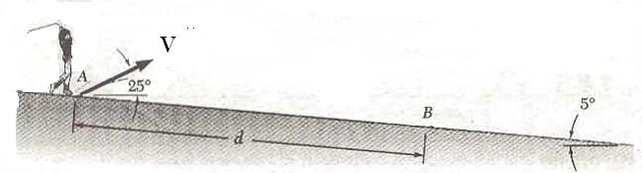 | 8  7
 | A 0.3 Kg block rests on top of a 0.23 Kg block supported by but not attached to a spring of constant 131.3 N/m. The upper block is suddenly removed. Determine i) the maximum velocity reached by the 0.23 Kg block, ii) the maximum height reached by the 0.23 Kg block.  0.3 kg  0.23 kg | 15
OR
A 10 Kg collar slides without friction along a vertical rod as shown. The spring attached to the collar has an undeformed length of 150 mm and a constant of 500 N/m. If the collar is released from the rest in position 1, determine its velocity after it has moved 150 mm to position 2.
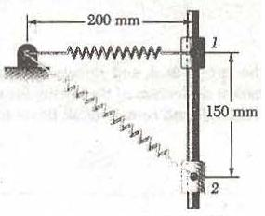

 | - A system consists of three particles A, B and C. At the instant considered, they are located as shown in figure and have velocity  V_{A} = (5 i – 8 k ) m/sec, V_{B} = ( 4 i + V_{y} j + Vz k m/sec and  V_{C} = ( 6 i + 3 j – 2 k) m/sec respectively. If the masses of these particles are m_{A} = 3 Kg, m_{B} = 1 Kg and m_{C} = 2 Kg, respectively and the resultant angular momentum H_{O} of the system about the origin is parallel to the z axis, determine the value of H_{O}.  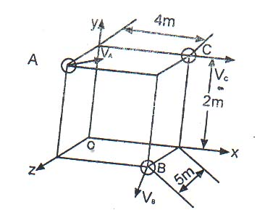  b) The angular acceleration of an oscillating disk is defined by the relation α = -kθ. Determine i) the value of k for which ω = 12 rad/sec when θ = 0 and θ = 6 radian when ω = 0 and ii) the angular velocity of the disk when θ = 3 rad. | 8  7
 | - Derive an expression for the tangential and normal component of acceleration of the body in a curvilinear motion.  - The 11.3 Kg double pulleys shown are at rest and in equilibrium when a constant 4.75 Nm couple M is applied. Neglecting the effect of friction and knowing that the radius of gyration of the double pulley is 15.2 cm, determine a) angular acceleration of the double pulley, b) the tension in each rope. Radius of internal pulley is 12 cm and external pulley is 16 cm.  5 N | 6  9
 | Write short notes on (Any Two) :  - Couple and its characteristics  - General Plane Motion  - Principle of conservation of energy | 2×5

